
Celebration of the Word – Part I Nehemiah 8

LightHouse Ranch
Bible Study
I. At the Water Gate
II. The Word Given with the Interpretation
III. As it is Written in Both Testaments
IV. The Charge Before God
After stating that the Law could never justify anyone:
Wherefore when he cometh into the world, he saith, Sacrifice and offering thou wouldest not, but a body hast thou prepared me: In burnt offerings and sacrifices for sin thou hast had no pleasure. Then said I, Lo, I come (in the volume of the book it is written of me,) to do thy will, O God. Above when he said, Sacrifice and offering and burnt offerings and offering for sin thou wouldest not, neither hadst pleasure therein; which are offered by the law; Then said he, Lo, I come to do thy will, O God. He taketh away the first, that he may establish the second. By the which will we are sanctified through the offering of the body of Jesus Christ once for all. And every priest standeth daily ministering and offering oftentimes the same sacrifices, which can never take away sins: But this man, after he had offered one sacrifice for sins for ever, sat down on the right hand of God; From henceforth expecting till his enemies be made his footstool. For by one offering he hath perfected for ever them that are sanctified. (Hebrews 10:5-14)
Celebration of the Word – Part I Nehemiah 8
 | Nehemiah
Scope | So the wall was finished in the twenty and fifth day of the month Elul, in fifty and two days. And it came to pass, that when all our enemies heard thereof, and all the heathen that were about us saw these things, they were much cast down in their own eyes: for they perceived that this work was wrought of our God. (Nehemiah 6:15-16)  So they read in the book in the law of God distinctly, and gave the sense, and caused them to understand the reading. (Nehemiah 8:8)
Reference | 2:18 | 7:73 | 12:47 | 13:31
Division | LORD Revealed through Opposition |  | The Word Celebrated
Plan | Before the God of Heaven | Opposition Defeated | Giving the Word  With the Interpretation | Sanctification and Restoration
The LORD continually gives us a typical, prophetic view of His work throughout the ages. In the Beginning God, is the way the Scriptural revelation begins to describe the eternal, righteous, omnipresent, and omnipotent God. He consists of the Creator (His Son) and power, (His Holy Spirit) . The LORD’s revelation of His only begotten Son continues with the scope of the Bible throughout the Scripture to the last book - that of the Revelation of His Son and His second Advent when every eye shall see Him. This typical journey through the Bible continues from Abraham, a type of God’s people along with the LORD teaching the walk of faith, then on to Moses who proclaimed God’s Word with many, many prophesies of what God is doing and will do. These prophesies also consist of the judgment God will have to begin if the people, “Do not harken to His Word and do not observe to do it.” In this prophesy, (Deuteronomy 28), the people will be removed from the land twice – the Babylonian Captivity and the Scattering. All of this while Moses himself was in Scripture a type of Christ. It is almost impossible not see the type of Christ in the story of Joseph at the end of Genesis.
Explaining the world’s problems and describing a “syndrome” in which we see the LORD’s people stuck: First worshiping God, on to disobedience, leading to bondage, then to deliverance, back to worship, disobedience, bondage, and again to the LORD’s deliverance; we find, as we continue in God’s Word, that it is sanctification which is needed – santification from the world and unto God. This sanctification has been taught in the Old Testament through the types of cleansing rituals, holy tabernacle furniture holy people and holy vessels. It is here we find Samuel, Jonathon, David, and Solomon all obvious types of Christ, showing us who He is and the glory of His kingdom to come.
It is, however, when we reach Ezra, Nehemiah, and Esther that we find in-depth types of the church age, Great Tribulation, and the Day of the LORD. It is here we find the deep need for the eternal, inspired, and preserved Word of God. The LORD begins this excursion with the great prophesy in Isaiah 44-45 calling Cyrus the Great 150-200 years before he was born. Yes, it was a Persian King, Cyrus, that made the proclamation to free God’s people from Babylonian Captivity. Zerubabbel and Joshua were used of God to lead the people back to Jerusalem, reinstitute the worship of God (feasts), and build the temple through much opposition. God sends two more prophets to guide the people, Haggai and Zechariah. The temple is rebuilt, which is a type of the BRANCH who will build the Millennial temple.
When we reach the Book of Ezra, however, we are, by type, learning about God’s remnant which He is calling. Not only learning what God was doing then, but also we learn what He will be doing to miracously save His remanant and show their need for sanctification – then and at the Great Tribulation.
It is in the story of Nehemiah and the building of the wall with world-wide style opposition that we learn typically of the coming Great Tribulation. Today, we will talk abou t God’s eternal Word and the LORD’s work of Returning His people back to Himself. What is taught by “sanctification” here in type?
I. At the Water Gate
All the people before the Water Gate
Nehemiah 8:1 And all the people gathered themselves together as one man into the street that was before the water gate; and they spake unto Ezra the scribe to bring the book of the law of Moses, which the LORD had commanded to Israel.
Ezra brings the Word of God
Nehemiah 8:2 And Ezra the priest brought the law before the congregation both of men and women, and all that could hear with understanding, upon the first day of the seventh month.
Nehemiah 8:3 And he read therein before the street that was before the water gate from the morning until midday, before the men and the women, and those that could understand; and the ears of all the people were attentive unto the book of the law.
Nehemiah 8:4 And Ezra the scribe stood upon a pulpit of wood, which they had made for the purpose; and beside him stood Mattithiah, and Shema, and Anaiah, and Urijah, and Hilkiah, and Maaseiah, on his right hand; and on his left hand, Pedaiah, and Mishael, and Malchiah, and Hashum, and Hashbadana, Zechariah, and Meshullam.
Nehemiah 8:5 And Ezra opened the book in the sight of all the people; (for he was above all the people;) and when he opened it, all the people stood up:
Nehemiah 8:6 And Ezra blessed the LORD, the great God. And all the people answered, Amen, Amen, with lifting up their hands: and they bowed their heads, and worshipped the LORD with their faces to the ground.
Nehemiah 8:7 Also Jeshua, and Bani, and Sherebiah, Jamin, Akkub, Shabbethai, Hodijah, Maaseiah, Kelita, Azariah, Jozabad, Hanan, Pelaiah, and the Levites, caused the people to understand the law: and the people stood in their place.
II. The Word Given with the Interpretation
They read distinctly – Gave the sense
Nehemiah 8:8 So they read in the book in the law of God distinctly, and gave the sense, and caused them to understand the reading.
All the people wept when they heard the Words
Nehemiah the govenor, Ezra the priest, and the teaching Levites – This day is holy – I Timothy 6
Nehemiah 8:9 And Nehemiah, which is the Tirshatha, and Ezra the priest the scribe, and the Levites that taught the people, said unto all the people, This day is holy unto the LORD your God; mourn not, nor weep. For all the people wept, when they heard the words of the law.
Nehemiah 8:10 Then he said unto them, Go your way, eat the fat, and drink the sweet, and send portions unto them for whom nothing is prepared: for this day is holy unto our Lord: neither be ye sorry; for the joy of the LORD is your strength.
ne8Nehemiah 8:11 So the Levites stilled all the people, saying, Hold your peace, for the day is holy; neither be ye grieved.
Nehemiah 8:12 And all the people went their way to eat, and to drink, and to send portions, and to make great mirth, because they had understood the words that were declared unto them.
The 2nd day – The fathers, priests, Levites come to understand the Words
Nehemiah 8:13 And on the second day were gathered together the chief of the fathers of all the people, the priests, and the Levites, unto Ezra the scribe, even to understand the words of the law.
Nehemiah 8:14 And they found written in the law which the LORD had commanded by Moses, that the children of Israel should dwell in booths in the feast of the seventh month:
Nehemiah 8:15 And that they should publish and proclaim in all their cities, and in Jerusalem, saying, Go forth unto the mount, and fetch olive branches, and pine branches, and myrtle branches, and palm branches, and branches of thick trees, to make booths, as it is written.
III. As it is Written in Both Testaments
I & II Timothy, written by Paul, under the inspiration of the LORD about doing the LORD’s work Scriptually. I Timothy begins with how families should direct their ways, but in chapter 6 and II Timothy the LORD narrows into the chosen and called of God’s ministry.
To those at the workplace
1 Timothy 6:1 Let as many servants as are under the yoke count their own masters worthy of all honour, that the name of God and his doctrine be not blasphemed.
1 Timothy 6:2 And they that have believing masters, let them not despise them, because they are brethren; but rather do them service, because they are faithful and beloved, partakers of the benefit. These things teach and exhort.
1 Timothy 6:3 If any man teach otherwise, and consent not to wholesome words, even the words of our Lord Jesus Christ, and to the doctrine which is according to godliness;
1 Timothy 6:4 He is proud, knowing nothing, but doting about questions and strifes of words, whereof cometh envy, strife, railings, evil surmisings,
1 Timothy 6:5 Perverse disputings of men of corrupt minds, and destitute of the truth, supposing that gain is godliness: from such withdraw thyself.
1 Timothy 6:6 But godliness with contentment is great gain.
1 Timothy 6:7 For we brought nothing into this world, and it is certain we can carry nothing out.
1 Timothy 6:8 And having food and raiment let us be therewith content.
To the rich in God’s service – A good profession – Not just confession
1 Timothy 6:9 But they that will be rich fall into temptation and a snare, and into many foolish and hurtful lusts, which drown men in destruction and perdition.
1 Timothy 6:10 For the love of money is the root of all evil: which while some coveted after, they have erred from the faith, and pierced themselves through with many sorrows.
1 Timothy 6:11 But thou, O man of God, flee these things; and follow after righteousness, godliness, faith, love, patience, meekness.
1 Timothy 6:12 Fight the good fight of faith, lay hold on eternal life, whereunto thou art also called, and hast professed a good profession before many witnesses.
1 Timothy 6:13 I give thee charge in the sight of God, who quickeneth all things, and before Christ Jesus, who before Pontius Pilate witnessed a good confession;
1 Timothy 6:14 That thou keep this commandment without spot, unrebukeable, until the appearing of our Lord Jesus Christ:
1 Timothy 6:15 Which in his times he shall shew, who is the blessed and only Potentate, the King of kings, and Lord of lords;
1 Timothy 6:16 Who only hath immortality, dwelling in the light which no man can approach unto; whom no man hath seen, nor can see: to whom be honour and power everlasting. Amen.
1 Timothy 6:17 Charge them that are rich in this world, that they be not highminded, nor trust in uncertain riches, but in the living God, who giveth us richly all things to enjoy;
1 Timothy 6:18 That they do good, that they be rich in good works, ready to distribute, willing to communicate;
1 Timothy 6:19 Laying up in store for themselves a good foundation against the time to come, that they may lay hold on eternal life.
To Timothy – Keep that which is commited to thy trust
1 Timothy 6:20 O Timothy, keep that which is committed to thy trust, avoiding profane and vain babblings, and oppositions of science falsely so called:
1 Timothy 6:21 Which some professing have erred concerning the faith. Grace be with thee. Amen.
2 Timothy 1:1 Paul, an apostle of Jesus Christ by the will of God, according to the promise of life which is in Christ Jesus,
2 Timothy 1:2 To Timothy, my dearly beloved son: Grace, mercy, and peace, from God the Father and Christ Jesus our Lord.
You are in my prayers every time I remember your unfeigned faith
2 Timothy 1:3 I thank God, whom I serve from my forefathers with pure conscience, that without ceasing I have remembrance of thee in my prayers night and day;
2 Timothy 1:4 Greatly desiring to see thee, being mindful of thy tears, that I may be filled with joy;
2 Timothy 1:5 When I call to remembrance the unfeigned faith that is in thee, which dwelt first in thy grandmother Lois, and thy mother Eunice; and I am persuaded that in thee also.
2 Timothy 1:6 Wherefore I put thee in remembrance that thou stir up the gift of God, which is in thee by the putting on of my hands.
2 Timothy 1:7 For God hath not given us the spirit of fear; but of power, and of love, and of a sound mind.
2 Timothy 1:8 Be not thou therefore ashamed of the testimony of our Lord, nor of me his prisoner: but be thou partaker of the afflictions of the gospel according to the power of God;
2 Timothy 1:9 Who hath saved us, and called us with an holy calling, not according to our works, but according to his own purpose and grace, which was given us in Christ Jesus before the world began,
2 Timothy 1:10 But is now made manifest by the appearing of our Saviour Jesus Christ, who hath abolished death, and hath brought life and immortality to light through the gospel:
2 Timothy 1:11 Whereunto I am appointed a preacher, and an apostle, and a teacher of the Gentiles.
For God’s cause Paul suffers these things
2 Timothy 1:12 For the which cause I also suffer these things: nevertheless I am not ashamed: for I know whom I have believed, and am persuaded that he is able to keep that which I have committed unto him against that day.
2 Timothy 1:13 Hold fast the form of sound words, which thou hast heard of me, in faith and love which is in Christ Jesus.
2 Timothy 1:14 That good thing which was committed unto thee keep by the Holy Ghost which dwelleth in us.
2 Timothy 1:15 This thou knowest, that all they which are in Asia be turned away from me; of whom are Phygellus and Hermogenes.
2 Timothy 1:16 The Lord give mercy unto the house of Onesiphorus; for he oft refreshed me, and was not ashamed of my chain:
2 Timothy 1:17 But, when he was in Rome, he sought me out very diligently, and found me.
2 Timothy 1:18 The Lord grant unto him that he may find mercy of the Lord in that day: and in how many things he ministered unto me at Ephesus, thou knowest very well.
Thou therefore, my son – don’t get entangled
2 Timothy 2:1 Thou therefore, my son, be strong in the grace that is in Christ Jesus.
2 Timothy 2:2 And the things that thou hast heard of me among many witnesses, the same commit thou to faithful men, who shall be able to teach others also.
2 Timothy 2:3 Thou therefore endure hardness, as a good soldier of Jesus Christ.
2 Timothy 2:4 No man that warreth entangleth himself with the affairs of this life; that he may please him who hath chosen him to be a soldier.
Even in war or sports if someone strives to win - not rewarded unless it is lawfully done
2 Timothy 2:5 And if a man also strive for masteries, yet is he not crowned, except he strive lawfully.
2 Timothy 2:6 The husbandman that laboureth must be first partaker of the fruits.
2 Timothy 2:7 Consider what I say; and the Lord give thee understanding in all things.
2 Timothy 2:8 Remember that Jesus Christ of the seed of David was raised from the dead according to my gospel:
2 Timothy 2:9 Wherein I suffer trouble, as an evil doer, even unto bonds; but the word of God is not bound.
2 Timothy 2:10 Therefore I endure all things for the elect's sakes, that they may also obtain the salvation which is in Christ Jesus with eternal glory.
2 Timothy 2:11 It is a faithful saying: For if we be dead with him, we shall also live with him:
2 Timothy 2:12 If we suffer, we shall also reign with him: if we deny him, he also will deny us:
2 Timothy 2:13 If we believe not, yet he abideth faithful: he cannot deny himself.
2 Timothy 2:14 Of these things put them in remembrance, charging them before the Lord that they strive not about words to no profit, but to the subverting of the hearers.
Study and do God’s Word in Context
2 Timothy 2:15 Study to shew thyself approved unto God, a workman that needeth not to be ashamed, rightly dividing the word of truth.
2 Timothy 2:16 But shun profane and vain babblings: for they will increase unto more ungodliness.
2 Timothy 2:17 And their word will eat as doth a canker: of whom is Hymenaeus and Philetus;
2 Timothy 2:18 Who concerning the truth have erred, saying that the resurrection is past already; and overthrow the faith of some.
2 Timothy 2:19 Nevertheless the foundation of God standeth sure, having this seal, The Lord knoweth them that are his. And, Let every one that nameth the name of Christ depart from iniquity.
2 Timothy 2:20 But in a great house there are not only vessels of gold and of silver, but also of wood and of earth; and some to honour, and some to dishonour.
2 Timothy 2:21 If a man therefore purge himself from these, he shall be a vessel unto honour, sanctified, and meet for the master's use, and prepared unto every good work.
2 Timothy 2:22 Flee also youthful lusts: but follow righteousness, faith, charity, peace, with them that call on the Lord out of a pure heart.
2 Timothy 2:23 But foolish and unlearned questions avoid, knowing that they do gender strifes.
2 Timothy 2:24 And the servant of the Lord must not strive; but be gentle unto all men, apt to teach, patient,
2 Timothy 2:25 In meekness instructing those that oppose themselves; if God peradventure will give them repentance to the acknowledging of the truth;
2 Timothy 2:26 And that they may recover themselves out of the snare of the devil, who are taken captive by him at his will.
All this, especially in these last days
2 Timothy 3:1 This know also, that in the last days perilous times shall come.
2 Timothy 3:2 For men shall be lovers of their own selves, covetous, boasters, proud, blasphemers, disobedient to parents, unthankful, unholy,
2 Timothy 3:3 Without natural affection, trucebreakers, false accusers, incontinent, fierce, despisers of those that are good,
2 Timothy 3:4 Traitors, heady, highminded, lovers of pleasures more than lovers of God;
2 Timothy 3:5 Having a form of godliness, but denying the power thereof: from such turn away.
2 Timothy 3:6 For of this sort are they which creep into houses, and lead captive silly women laden with sins, led away with divers lusts,
2 Timothy 3:7 Ever learning, and never able to come to the knowledge of the truth.
2 Timothy 3:8 Now as Jannes and Jambres withstood Moses, so do these also resist the truth: men of corrupt minds, reprobate concerning the faith.
2 Timothy 3:9 But they shall proceed no further: for their folly shall be manifest unto all men, as theirs also was.
You have fully known my doctrine – It’s the Word
2 Timothy 3:10 But thou hast fully known my doctrine, manner of life, purpose, faith, longsuffering, charity, patience,
2 Timothy 3:11 Persecutions, afflictions, which came unto me at Antioch, at Iconium, at Lystra; what persecutions I endured: but out of them all the Lord delivered me.
2 Timothy 3:12 Yea, and all that will live godly in Christ Jesus shall suffer persecution.
2 Timothy 3:13 But evil men and seducers shall wax worse and worse, deceiving, and being deceived.
2 Timothy 3:14 But continue thou in the things which thou hast learned and hast been assured of, knowing of whom thou hast learned them;
2 Timothy 3:15 And that from a child thou hast known the holy scriptures, which are able to make thee wise unto salvation through faith which is in Christ Jesus.
2 Timothy 3:16 All scripture is given by inspiration of God, and is profitable for doctrine, for reproof, for correction, for instruction in righteousness:
2 Timothy 3:17 That the man of God may be perfect, throughly furnished unto all good works.
IV. The Charge before God
2 Timothy 4:1 I charge thee therefore before God, and the Lord Jesus Christ, who shall judge the quick and the dead at his appearing and his kingdom;
2 Timothy 4:2 Preach the word; be instant in season, out of season; reprove, rebuke, exhort with all longsuffering and doctrine.
2 Timothy 4:3 For the time will come when they will not endure sound doctrine; but after their own lusts shall they heap to themselves teachers, having itching ears;
2 Timothy 4:4 And they shall turn away their ears from the truth, and shall be turned unto fables.
2 Timothy 4:5 But watch thou in all things, endure afflictions, do the work of an evangelist, make full proof of thy ministry.
2 Timothy 4:6 For I am now ready to be offered, and the time of my departure is at hand.
2 Timothy 4:7 I have fought a good fight, I have finished my course, I have kept the faith:
2 Timothy 4:8 Henceforth there is laid up for me a crown of righteousness, which the Lord, the righteous judge, shall give me at that day: and not to me only, but unto all them also that love his appearing.
Time of the Feasts
Months of the New Calendar year the feasts of God are Celebrated
Feasts | 1st Three Feasts | Pentecost | Last Three Feasts
Months | March / April | May / June | September/ October
Season | Spring | Summer - 50 Days after Firstfruits | Fall
Advent | Christ’s First Advent | Holy Ghost Advent | Christ’s Second Advent
References of the Feasts
Name of Feast | Reference | Type
Passover | Exodus 12:1-10; Leviticus 23:1-5 | Redemption
Unleavened Bread | Exodus 12:10-20; Leviticus 23:6-8 | Sanctification
First Fruits | Leviticus 23:9-14 | Resurrection
Pentecost | Leviticus 23:15-22 | Advent of the Holy Spirit - Church Begins
Trumpets | Leviticus 23:23-25 | Rapture of the Church
Day of Atonement | Leviticus 23:26-32 | Israel Restored @ 2nd Advent of Christ
Tabernacles | Leviticus 23:33-44 | Millennium
Foreshadow of the Feasts
Name of the Feast | Reference | Hebrew Name | Foreshadow | Foreshadow Reference
Passover | Leviticus 23:1-5  Exodus 12:1-10 | Pesch | Redemption  1st Advent of Christ | I Corinthians 5:7; Romans 3-4
Unleavened Bread | Leviticus 23:6-8  Exodus 12:10-20 | Matza | Sanctification | I Corinthians 5:8; Romans 5-8:20
First Fruits | Leviticus 23:9-14 | Ray-sheeth, Barley & Flax | Resurrection – Firstfruits of them that slept | I Corinthians 15
Pentecost | Leviticus 23:15-22 | Shavuot (Weeks) | Advent of the Holy Spirit (church)  Type of Spirit pouring upon Israel | John 20 - Acts 2 - Joel 2
Hebrew summer harvest for 4 months between feasts foreshadows:  The church sent by Christ to sew the summer (wheat) field |  |  |  | John 4:28 - 42; 20:18-23  Luke 19:1-27; Matt. 13
Trumpets | (22 as transition)  Leviticus 23:23-25  Numbers29:1-6 | Rosh Hashanah (New Year)  (Yam Teruah) | Type of Rapture of the Church,  Tribulation Resurrections, and Israel’s return (Daniel 12:1-3) | I Thessalonians 4:12 - 18  I Corinthians 15:50-58  John 14:1-4
Day of Atonement | Leviticus 23:26-32 | Yom Kippur | Israel’s Restoration  2nd Advent of Christ | Leviticus 16; Zechariah 12; Romans 11; Ezekiel 37-39
Tabernacles | Leviticus 23:33-44 | Sukkot | Millennium | Zechariah 14; Nehemiah  Revelation 19-20
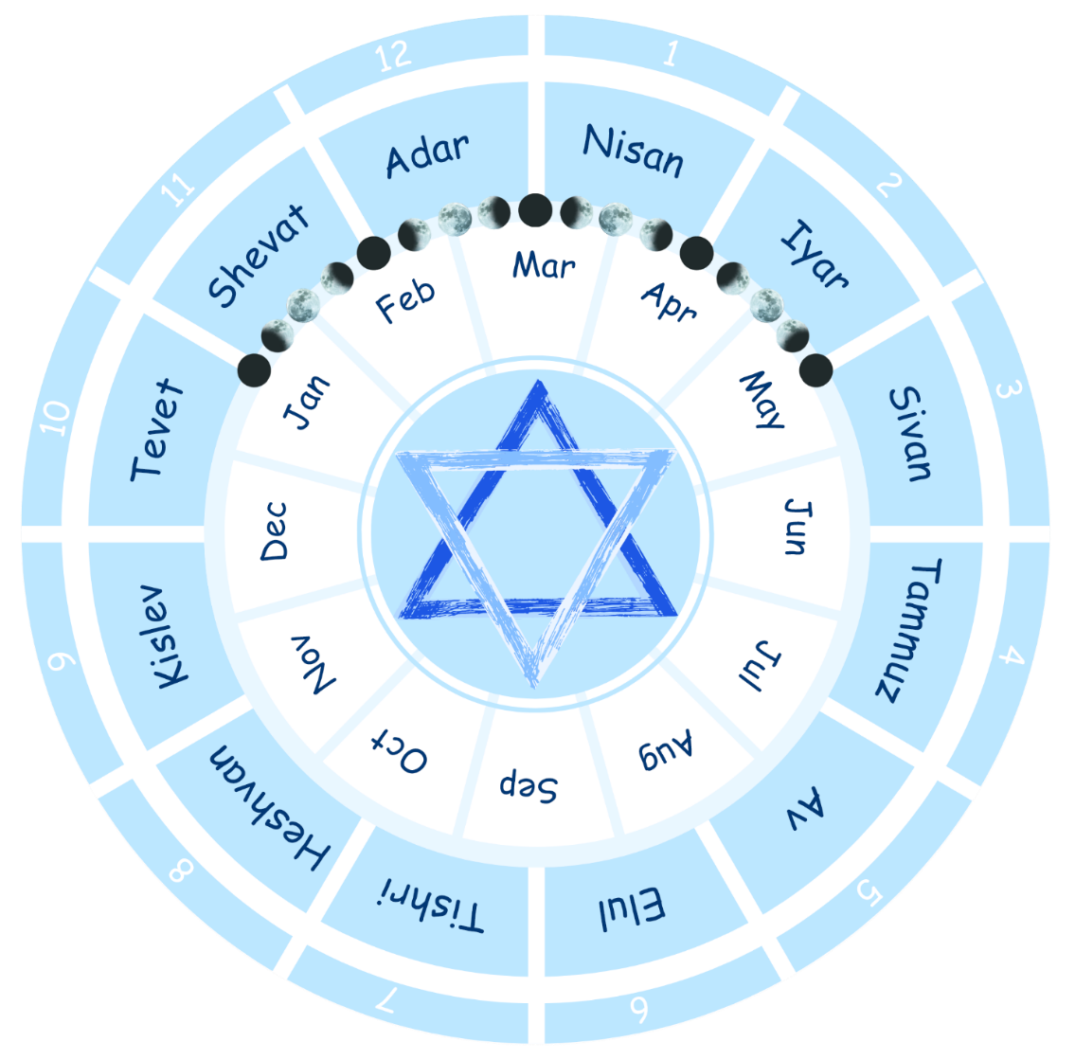
Feast of Tabernacles Observed Scripturally – Refers back to Joshua
Nehemiah 8:16 So the people went forth, and brought them, and made themselves booths, every one upon the roof of his house, and in their courts, and in the courts of the house of God, and in the street of the water gate, and in the street of the gate of Ephraim.
Nehemiah 8:17 And all the congregation of them that were come again out of the captivity made booths, and sat under the booths: for since the days of Jeshua the son of Nun unto that day had not the children of Israel done so. And there was very great gladness.
Nehemiah 8:18 Also day by day, from the first day unto the last day, he read in the book of the law of God. And they kept the feast seven days; and on the eighth day was a solemn assembly, according unto the manner.

