LightHouse Ranch
Bible Study
Exodus 40 God Works through His Types
I. Scripture is the Witness
II. Tabernacle and Furniture Symbols
III. Types in the Tabernacle
IV. Priests & Garments Portray Christ
V. The Vail Speaks of Christ
VI. Moses a type of Christ
VII. Why does Moses get all the credit?

Exodus chapter 40 – God works through His Types
I. Introduction – Scripture is the Witness (In the volume of the Book it is written of me)
As we study the founding of our beloved country, we encounter great people, with Bible knowledge, seeking God to form a government that conforms with God’s desire in which He created each individual in His own image the ability to speak with and seek God - and with free will. For the last 100 years or so this philosophy of liberty and consent of the governed has, in too many places, been replaced by the tyranny of “experts” who supposedly know better than the people, Congress, or the Founders who formed the government with both separation of powers and checks and balances, all designed to prevent tyranny. Today, rather than Congress making all the laws, we have tyranny as unconstitutional agencies of unelected “experts” execute hundreds of mandates. We have hope because the Declaration of Independence and the Constitution are still here. With God’s help, we can restore the godly liberty of the Founder’s “original intent”. This liberty enables God’s people to give out God’s Word as He desires.
One of the parallels we can see between Israel and the U.S. is vividly exposed in John 5. Jesus, going to a feast, goes out of His way to teach the woman at the well, as well as her acquaintances of Samaria, concerning the “living water” - water with which Christ came down to Earth to give to any individual who is thirsty. If a thirsty person drinks of that living water, he or she will never thirst again. This living water does not come from religion or the education of this world, but rather only from God. We find that this living water here on earth is the cleansing power of God’s Word – not of the letter, but “what God meant when He wrote it” - or the “Spirit of the Word”. In eternity, however, we find this living water is called the “water of life”:
And he that sat upon the throne said, Behold, I make all things new. And he said unto me, Write: for these words are true and faithful. And he said unto me, It is done. I am Alpha and Omega, the beginning and the end. I will give unto him that is athirst of the fountain of the water of life freely. He that overcometh shall inherit all things; and I will be his God, and he shall be my son. (Revelation 21:5-7)
It is interesting how this Great Teacher, Jesus, continues this teaching at the feast:
The belief of the day was the moving water, if you could get in first, you could be healed
John 5:1 After this there was a feast of the Jews; and Jesus went up to Jerusalem.
John 5:2 Now there is at Jerusalem by the sheep market a pool, which is called in the Hebrew tongue Bethesda, having five porches.
John 5:3 In these lay a great multitude of impotent folk, of blind, halt, withered, waiting for the moving of the water.
John 5:4 For an angel went down at a certain season into the pool, and troubled the water: whosoever then first after the troubling of the water stepped in was made whole of whatsoever disease he had.
John 5:5 And a certain man was there, which had an infirmity thirty and eight years.
John 5:6 When Jesus saw him lie, and knew that he had been now a long time in that case, he saith unto him, Wilt thou be made whole?
The impotent man answers Christ with the thought of the day
John 5:7 The impotent man answered him, Sir, I have no man, when the water is troubled, to put me into the pool: but while I am coming, another steppeth down before me.
Jesus commands him to be healed – The Word of God
John 5:8 Jesus saith unto him, Rise, take up thy bed, and walk.
The man was healed, but the “experts”, who have changed God’s Word, don’t like it.
John 5:9 And immediately the man was made whole, and took up his bed, and walked: and on the same day was the sabbath.
The “experts”, God’s appointed leaders, now tell the man he has broken the Law.
John 5:10 The Jews therefore said unto him that was cured, It is the sabbath day: it is not lawful for thee to carry thy bed.
The now healed man testified that the one who had healed him told him to carry his bed.
John 5:11 He answered them, He that made me whole, the same said unto me, Take up thy bed, and walk.
John 5:12 Then asked they him, What man is that which said unto thee, Take up thy bed, and walk?
John 5:13 And he that was healed wist not who it was: for Jesus had conveyed himself away, a multitude being in that place.
But the healed man has another encounter with Christ, hearing an important message
John 5:14 Afterward Jesus findeth him in the temple, and said unto him, Behold, thou art made whole: sin no more, lest a worse thing come unto thee.
Now, knowing who the healer was, informed the Jews
John 5:15 The man departed, and told the Jews that it was Jesus, which had made him whole.
John 5:16 And therefore did the Jews persecute Jesus, and sought to slay him, because he had done these things on the sabbath day.
Now, Jesus, the One who wrote the Law, speaks to the Pharisees
John 5:17 But Jesus answered them, My Father worketh hitherto, and I work.
John 5:18 Therefore the Jews sought the more to kill him, because he not only had broken the sabbath, but said also that God was his Father, making himself equal with God.
John 5:19 Then answered Jesus and said unto them, Verily, verily, I say unto you, The Son can do nothing of himself, but what he seeth the Father do: for what things soever he doeth, these also doeth the Son likewise.
John 5:20 For the Father loveth the Son, and sheweth him all things that himself doeth: and he will shew him greater works than these, that ye may marvel.
John 5:21 For as the Father raiseth up the dead, and quickeneth them; even so the Son quickeneth whom he will.
John 5:22 For the Father judgeth no man, but hath committed all judgment unto the Son:
John 5:23 That all men should honour the Son, even as they honour the Father. He that honoureth not the Son honoureth not the Father which hath sent him.
John 5:24 Verily, verily, I say unto you, He that heareth my word, and believeth on him that sent me, hath everlasting life, and shall not come into condemnation; but is passed from death unto life.
John 5:25 Verily, verily, I say unto you, The hour is coming, and now is, when the dead shall hear the voice of the Son of God: and they that hear shall live.
John 5:26 For as the Father hath life in himself; so hath he given to the Son to have life in himself;
John 5:27 And hath given him authority to execute judgment also, because he is the Son of man.
John 5:28 Marvel not at this: for the hour is coming, in the which all that are in the graves shall hear his voice,
John 5:29 And shall come forth; they that have done good, unto the resurrection of life; and they that have done evil, unto the resurrection of damnation.
Jesus follows the Law – It takes 2 or 3 witnesses – There are many witnesses in Scripture
John 5:30 I can of mine own self do nothing: as I hear, I judge: and my judgment is just; because I seek not mine own will, but the will of the Father which hath sent me.
John 5:31 If I bear witness of myself, my witness is not true.
John 5:32 There is another that beareth witness of me; and I know that the witness which he witnesseth of me is true.
There is yet another witness of Christ sent from the Father – A burning and shining light
John 5:33 Ye sent unto John, and he bare witness unto the truth.
John 5:34 But I receive not testimony from man: but these things I say, that ye might be saved.
John 5:35 He was a burning and a shining light: and ye were willing for a season to rejoice in his light.
But yet the “works” that Christ does is a greater witness that Christ was sent by the Father
John 5:36 But I have greater witness than that of John: for the works which the Father hath given me to finish, the same works that I do, bear witness of me, that the Father hath sent me.
Why can’t these emissaries of the Father recognize who Christ is? – No Word abiding in them
John 5:37 And the Father himself, which hath sent me, hath borne witness of me. Ye have neither heard his voice at any time, nor seen his shape.
John 5:38 And ye have not his word abiding in you: for whom he hath sent, him ye believe not.
Now look what Christ commands these political and religious leaders!
John 5:39 Search the scriptures; for in them ye think ye have eternal life: and they are they which testify of me.
John 5:40 And ye will not come to me, that ye might have life.
John 5:41 I receive not honour from men.
John 5:42 But I know you, that ye have not the love of God in you.
This is a prophesy, not just given to these particular leaders, but to all the leaders of Israel
John 5:43 I am come in my Father's name, and ye receive me not: if another shall come in his own name, him ye will receive.
Why cannot these leaders believe Who Christ is?
John 5:44 How can ye believe, which receive honour one of another, and seek not the honour that cometh from God only?
John 5:45 Do not think that I will accuse you to the Father: there is one that accuseth you, even Moses, in whom ye trust.
John 5:46 For had ye believed Moses, ye would have believed me: for he wrote of me.
John 5:47 But if ye believe not his writings, how shall ye believe my words?
Symbols in the Tabernacle
Item | Speaks of | Reference
Gold | Christ’s Deity | 1 Corinthians 3:11-17, Revelation 21:10-27
Silver | Redemption | Numbers 3:44-51; Exodus 36:24, 30:15
Brass | Judgement | Exodus 27:1-5, Numbers 21:4-9, Revelation 1:15
Blue | Heavens/heavenly nature | Exodus 25:4, 26:31, 28:31
Purple | Kingly/Royalty | John 19:2, Revelation 17:4-5
Scarlet | Blood Sacrifice | Leviticus 14:1-9, Joshua 2:1-24, Isaiah 1:16-20
Fine Linen | Righteousness | Leviticus 6:8-13, Revelation 19:4-10
Goats/Rams Hair | Atonement | Genesis 15, Exodus 12:3-20
Shittim | Jesus' Humanity | Exodus 26:15, Isaiah 52:7-53.12
Oil | Power of the Holy Spirit | Leviticus 14:15-18, Psalm 47:7

II. Tabernacle and Furniture Typical Of Christ
Boards and Sockets Boards And Sockets Typify Christ Symbolic of Christ and His Work
Boards made of shittim wood -  Indestructible desert wood – Resists termites | Speaks of Christ’s Humanity –A Root out of dry ground – Isaiah 52:7-53.12
Boards overlaid with pure gold | Symbolic Of Christ’s Deity Revelation 21:10-27
Shittim wood plus pure gold make up one board | God set aside His godly powers to become a man and die. A mystery of which many wise don’t understand  I Corinthians 1:23-31; Matthew 11:25-30; Philippians 2
Boards seated in sockets of silver | Redemption, delivering us from this present evil world Galatians 1:3-4; Numbers 3:44-51; Exodus 36:24, 30:15
Boards held together by bars | Christ holding all things together – Colossians 1:13-17
III. The types in the Tabernacle
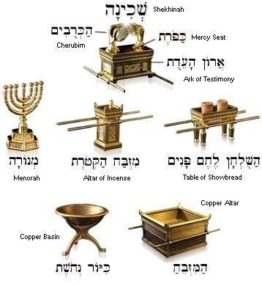 | 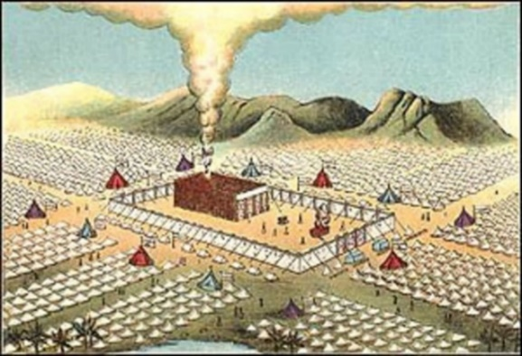
Earthly Tabernacle Tabernacle Furniture Type of Christ And His Work
God’s purpose - dwell with His people Exodus 25:8 | Revelation 21:3 …the tabernacle of God is with men, and he will dwell with them, …
Patterned from heaven – Exodus 25:8-9; Acts 7:44 | Christ Presented His Blood – Hebrews 9:6-28;
Ark of the covenant made of shittim wood overlaid with gold (resists termites, etc.) | 1. Indestructible Wood speaks of Christ’s Humanity  I Timothy 3:16; Colossians 2:6-10; Isaiah 7:14  2. Gold of His deity - Isaiah 9.6-7; Matthew 1:23
Mercy Seat where the meeting took place.  2. Between the cherubim – Exodus 25:22 | 1. God between the cherubim – Psalm 80:1; 99:1  2. Now, God dwells in those in Christ – John 14:23-24
Contents of the Ark: - Exodus 25:10-22  1; Table of the Covenant  2. Golden pot of manna  3. Aaron’s Rod that budded | 1. Christ as King – Fulfilling God’s Plan – Psalm 2  2. Christ as Prophet - The Bread of Life – John 6:31-40  3. Christ as Priest at resurrection - Hebrews 7:25, 9:1-28, 10:19-24; I Peter 1:18-19
Table of Shewbread – Exodus 25:23-30  1. Eaten by priests every Sabbath  2. His sinless life – Hebrews 9:28  3. Always present – priestly duties Hebrews 7:21-27 | 1. Christ Is bread of Life John 6:35-58; Matthew 22:1-14  2. Unleavened Bread (symbol of sin) Sanctification  3. Christ Our Eternal Priest – Hebrews 7:25-28
Golden Candlestick Exodus 25:31-40  1. Made of Gold  2. Looked like almond branches  3. Contained oil lamps  4. Only Light in the Tabernacle  5. Priest could not see to serve without the light  6. Light Revealed the beauty of the Candlestick | 1. Mystery of God and Christ – Colossians 2:2-23  2. Branches feed from the vine – John 15  3. Oil fuels the lamp Leviticus 14:15-18  4. Christ Is The Only Light John 8:12; 9:5  5. Must Walk in the Light I John 1:2-9  6. Holy Spirit Testifies Of Christ – John 15:26-27

IV. Priests and Garments Portray Christ
Exodus 28 | Reference | Garment | High Priest
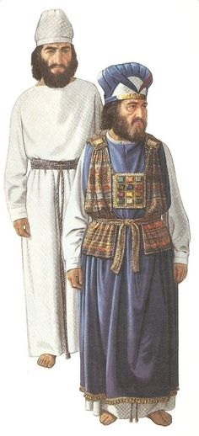 | 28:5-14 | Ephod - outer garment of gold, blue, and purple, scarlet, and fine-twined linen worn over the robe joined with shoulder pieces
 | 28:15-30 | Breastplate of Judgment 12 stones representing the 12 tribes with a pocket in which to put the Urim and Thummim - used to seek God's will. | High priest only
 | 28:31-35 | Mitre - holy crown of gold, engraved with: "Holiness to the Lord." | High priest only
 | 28:36-38 | Robe of the ephod, made of blue cloth, the hem with alternating embroidered pomegranates and gold bells. | High priest only
 | 28:39 | Linen coat & mitre with girdle of needlework | High Priest and Aaron’s sons
 | 28:40 | Coats, girdles, bonnets | Aaron’s sons
 | 28:42-43 | Linen breeches | High Priest and Aaron’s sons
Exodus 28:41 And thou shalt put them upon Aaron thy brother, and his sons with him; and shalt anoint them, and consecrate them, and sanctify them, that they may minister unto me in the priest's office.
V. The Vail Speaks of Christ
Vail Vail Speaks of Christ’s Body – Hebrews 10 Type
Exodus 26:31-37  Vail Made Of:  1. Fine Twined Linen  2. With Blue  3. With Scarlet  4. With Purple  5. With Cherubim | 1. White linen - righteousness – Revelation 19:8;  2. Christ’s Beauty – Psalm 27.4; 90.17  3. Blue -heaven - Exodus 25:4, 26:31, 28:31  4. Scarlet - shedding of Christ’s blood. Leviticus 14:1-9, Joshua 2:1-24, Isaiah 1:16-20  5. Purple - royalty – (Heaven touching earth as King) - John 19:2, Revelation 17:4-5  6. Cherubim - guardians of God’s throne - Genesis 3:24; Great place to hide Psalm 17:8
Four pillars made of shittim wood overlaid with gold standing in silver sockets to hang the vail | Pictures deity taking hold of earth Matthew 22:35-40
The Vail was a type of Christ’s body | Hebrews 10:20; Ephesians 2:13-18
The Vail was rent in two at Christ’s death | Matthew 27:50-51; Mark 15:38; Luke 23:45
The Vail was the only entrance to the Holy of Holies – Exodus 26:31-37 | Christ is the way, the truth, and the life, no one can approach the father except through Christ – John 14:6
The Vail was only a type, a shadow of good things to come – Hebrews 10:1-4 | Christ made a new and living way – Hebrews 10:9-22

VI. Moses a type of Christ – Exodus 40
Moses Moses, A Type of Christ Jesus Christ
Pharoah tried to slay the infant (Exodus 1:15–22). | Herod tried to slay the infant (Matthew 2:7–18).
A miracle birth (Exodus 2:1–16). | A miracle birth (Luke 1:27–38).
Did signs and miracles (Exodus 4:28–31). | Performed many other signs (John 20:30).
Fasted forty days and forty nights (Exodus 34:28; Deuteronomy 9:9-18). | Fasted forty days and forty nights (Matthew. 4:2).
A mediator between Israel and God (Exodus 20:19–22). | Is the “one mediator between God and men” (I Timothy 2:5).
Controlled the sea and the wind (Exodus 14:21-27) | Controlled the sea and the wind (Luke 8:23-25)
Aided by 12 tribe leaders and 70 men (Exodus 24:1-9; Numbers 1:4-19; 11:16-29). | Aided by 12 Apostles and 70 men (Matthew 10:1–22; Mark 3:14–30; Luke 6:13–19; 10:1–27).
Sent from God (Exodus 3:1–12) | The “Father hath sent [Jesus]” (John 6:57-58)
By miracle, fed the people (Exodus 16:1–36) | By miracle, “that prophet” fed the people (Matthew 14:15–21; 15:33–38; Mark 6:35–44; Luke 9:12–17; John 1:21; John 6:5–15)
Delivered Israel from Egypt’s bondage (Exodus 3:1–14) | Grace reigns through righteousness unto eternal life by Jesus Christ our Lord (Romans 5.20-6.23)
Prophesied of the King of Jeshurun (Deuteronomy 33:1-5) | Is the King of the Universe (Psalm 2; Revelation 19)
Teacher (Deuteronomy 4) | Teacher (Matthew 5; John 3-4)
Prophet (Deuteronomy 18:15–19) | Prophet (Deuteronomy 18:15-19)
Lawgiver (Exodus 31:12-18) | Lawgiver (Isaiah 33:22; John 1:17)
“Moses faithful in all His house” (Hebrews 3:1-4) | Jesus was “faithful to Him that appointed Him” and built the house (Hebrews 3:1-4)
Did great wonders and signs (Exodus 14:21–31) | “Many other signs truly did Jesus” (John 20:30-31)
After his rejection, Moses took a Gentile Bride. Exodus 2:15-16; Exodus 2:21-22 | After His rejection, Christ is now gathering His mostly Gentile Bride. Ephesians 5.25-32
Present at the Transfiguration (Matthew 17) | Present at the Transfiguration (Matthew 17:1-5)
Moses prophesied about “that Prophet”.  The LORD thy God will raise up unto thee a Prophet from the midst of thee, of thy brethren, like unto me; unto him ye shall hearken; According to all that thou desiredst of the LORD thy God in Horeb in the day of the assembly, saying, Let me not hear again the voice of the LORD my God, neither let me see this great fire any more, that I die not. And the LORD said unto me, They have well spoken that which they have spoken. I will raise them up a Prophet from among their brethren, like unto thee, and will put my words in his mouth; and he shall speak unto them all that I shall command him. And it shall come to pass, that whosoever will not hearken unto my words which he shall speak in my name, I will require it of him.  (Deuteronomy 18:15-19) | The Divine Commentary points out who He is.  He brought them out, after that he had shewed wonders and signs in the land of Egypt, and in the Red sea, and in the wilderness forty years. This is that Moses, which said unto the children of Israel, A prophet shall the Lord your God raise up unto you of your brethren, like unto me; him shall ye hear. This is he, that was in the church in the wilderness with the angel which spake to him in the mount Sina, and with our fathers: who received the lively oracles to give unto us: To whom our fathers would not obey, but thrust him from them, and in their hearts turned back again into Egypt, Saying unto Aaron, Make us gods to go before us: for as for this Moses, which brought us out of the land of Egypt, we wot not what is become of him. (Acts 7:36-40)

One year since being redeemed from Egypt - Moses sets up the tent of the congregation
Exodus 40:1 And the LORD spake unto Moses, saying,
Exodus 40:2 On the first day of the first month shalt thou set up the tabernacle of the tent of the congregation.
Exodus 40:3 And thou shalt put therein the ark of the testimony, and cover the ark with the vail.
Exodus 40:4 And thou shalt bring in the table, and set in order the things that are to be set in order upon it; and thou shalt bring in the candlestick, and light the lamps thereof.
Exodus 40:5 And thou shalt set the altar of gold for the incense before the ark of the testimony, and put the hanging of the door to the tabernacle.
Exodus 40:6 And thou shalt set the altar of the burnt offering before the door of the tabernacle of the tent of the congregation.
Exodus 40:7 And thou shalt set the laver between the tent of the congregation and the altar, and shalt put water therein.
Exodus 40:8 And thou shalt set up the court round about, and hang up the hanging at the court gate.
Exodus 40:9 And thou shalt take the anointing oil, and anoint the tabernacle, and all that is therein, and shalt hallow it, and all the vessels thereof: and it shall be holy.
Exodus 40:10 And thou shalt anoint the altar of the burnt offering, and all his vessels, and sanctify the altar: and it shall be an altar most holy.
Exodus 40:11 And thou shalt anoint the laver and his foot, and sanctify it.
Exodus 40:12 And thou shalt bring Aaron and his sons unto the door of the tabernacle of the congregation, and wash them with water.
Exodus 40:13 And thou shalt put upon Aaron the holy garments, and anoint him, and sanctify him; that he may minister unto me in the priest's office.
Exodus 40:14 And thou shalt bring his sons, and clothe them with coats:
Exodus 40:15 And thou shalt anoint them, as thou didst anoint their father, that they may minister unto me in the priest's office: for their anointing shall surely be an everlasting priesthood throughout their generations.
Exodus 40:16 Thus did Moses: according to all that the LORD commanded him, so did he.
Exodus 40:17 And it came to pass in the first month in the second year, on the first day of the month, that the tabernacle was reared up.
There is still more for Moses to do
Exodus 40:18 And Moses reared up the tabernacle, and fastened his sockets, and set up the boards thereof, and put in the bars thereof, and reared up his pillars.
Exodus 40:19 And he spread abroad the tent over the tabernacle, and put the covering of the tent above upon it; as the LORD commanded Moses.
Exodus 40:20 And he took and put the testimony into the ark, and set the staves on the ark, and put the mercy seat above upon the ark:
Exodus 40:21 And he brought the ark into the tabernacle, and set up the vail of the covering, and covered the ark of the testimony; as the LORD commanded Moses.
Exodus 40:22 And he put the table in the tent of the congregation, upon the side of the tabernacle northward, without the vail.
Exodus 40:23 And he set the bread in order upon it before the LORD; as the LORD had commanded Moses.
Exodus 40:24 And he put the candlestick in the tent of the congregation, over against the table, on the side of the tabernacle southward.
Exodus 40:25 And he lighted the lamps before the LORD; as the LORD commanded Moses.
Exodus 40:26 And he put the golden altar in the tent of the congregation before the vail:
Exodus 40:27 And he burnt sweet incense thereon; as the LORD commanded Moses.
Exodus 40:28 And he set up the hanging at the door of the tabernacle.
Exodus 40:29 And he put the altar of burnt offering by the door of the tabernacle of the tent of the congregation, and offered upon it the burnt offering and the meat offering; as the LORD commanded Moses.
Exodus 40:30 And he set the laver between the tent of the congregation and the altar, and put water there, to wash withal.
Exodus 40:31 And Moses and Aaron and his sons washed their hands and their feet thereat:
Exodus 40:32 When they went into the tent of the congregation, and when they came near unto the altar, they washed; as the LORD commanded Moses.
So Moses finished the work
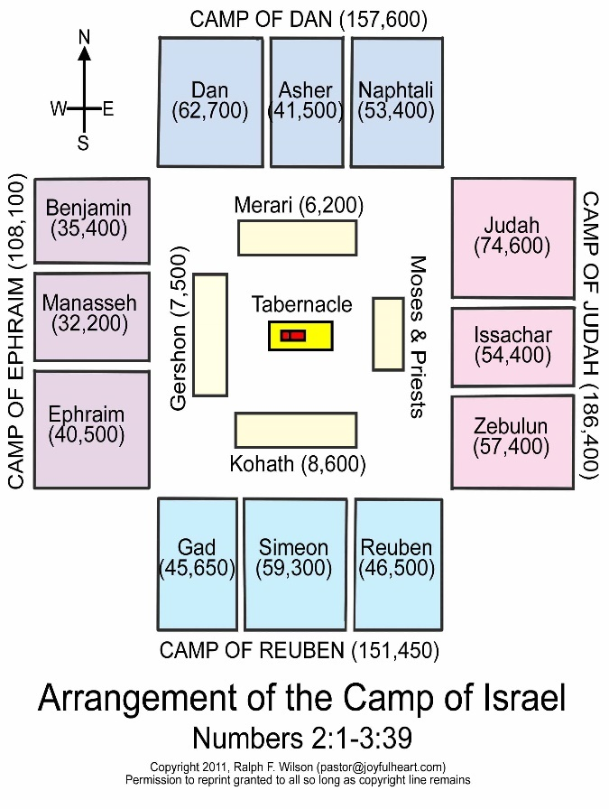 | Exodus 40:33 And he reared up the court round about the tabernacle and the altar, and set up the hanging of the court gate. So Moses finished the work.  Exodus 40:34 Then a cloud covered the tent of the congregation, and the glory of the LORD filled the tabernacle.  Exodus 40:35 And Moses was not able to enter into the tent of the congregation, because the cloud abode thereon, and the glory of the LORD filled the tabernacle.  Exodus 40:36 And when the cloud was taken up from over the tabernacle, the children of Israel went onward in all their journeys:  Exodus 40:37 But if the cloud were not taken up, then they journeyed not till the day that it was taken up.  Exodus 40:38 For the cloud of the LORD was upon the tabernacle by day, and fire was on it by night, in the sight of all the house of Israel, throughout all their journeys.
VII. Why does all the credit go to Moses? Many were responsible for the work?
Remember the offering taken and the people gave too much?
Exodus 36:6 And Moses gave commandment, and they caused it to be proclaimed throughout the camp, saying, Let neither man nor woman make any more work for the offering of the sanctuary. So the people were restrained from bringing.
Exodus 36:7 For the stuff they had was sufficient for all the work to make it, and too much.
Remember Bezaleel and Aholiab and everyone whose heart stirred him did the work?
Exodus 36:1 Then wrought Bezaleel and Aholiab, and every wise hearted man, in whom the LORD put wisdom and understanding to know how to work all manner of work for the service of the sanctuary, according to all that the LORD had commanded.
Exodus 36:2 And Moses called Bezaleel and Aholiab, and every wise hearted man, in whose heart the LORD had put wisdom, even every one whose heart stirred him up to come unto the work to do it:

Why should Moses get all the credit for the Tabernacle of the Tent of the Congregation?
Let’s return to Exodus 14, to begin to understand what God is doing. Israel has just been redeemed by the blood and by power, laden down with unbelievable gifts from Egypt to get rid of them, and Pharoah changes his mind. As Pharoah and his army close them in between mountains and the sea:
Exodus 14:10 And when Pharaoh drew nigh, the children of Israel lifted up their eyes, and, behold, the Egyptians marched after them; and they were sore afraid: and the children of Israel cried out unto the LORD.
Exodus 14:11 And they said unto Moses, Because there were no graves in Egypt, hast thou taken us away to die in the wilderness? wherefore hast thou dealt thus with us, to carry us forth out of Egypt?
If it wasn’t for Moses, the people would have never left Egypt! – Moses was their Intercessor.
This reminds me of Paul, speaking about the division in the church, prays about God’s will in them:
Hebrews 13:20 Now the God of peace, that brought again from the dead our Lord Jesus, that great shepherd of the sheep, through the blood of the everlasting covenant,
Hebrews 13:21 Make you perfect in every good work to do his will, working in you that which is wellpleasing in his sight, through Jesus Christ; to whom be glory for ever and ever. Amen.
Remember when God was chastening Israel and the Amalekites attached?
Exodus 17:9 And Moses said unto Joshua, Choose us out men, and go out, fight with Amalek: to morrow I will stand on the top of the hill with the rod of God in mine hand.
Exodus 17:10 So Joshua did as Moses had said to him, and fought with Amalek: and Moses, Aaron, and Hur went up to the top of the hill.
Exodus 17:11 And it came to pass, when Moses held up his hand, that Israel prevailed: and when he let down his hand, Amalek prevailed.
Exodus 17:12 But Moses' hands were heavy; and they took a stone, and put it under him, and he sat thereon; and Aaron and Hur stayed up his hands, the one on the one side, and the other on the other side; and his hands were steady until the going down of the sun.
Exodus 17:13 And Joshua discomfited Amalek and his people with the edge of the sword.
If it wasn’t for Moses playing the type of Christ, Israel would not have discomfited Amalek!
In the same manor Christ is at work today:
Hebrews 12:11 Now no chastening for the present seemeth to be joyous, but grievous: nevertheless afterward it yieldeth the peaceable fruit of righteousness unto them which are exercised thereby.
Hebrews 12:12 Wherefore lift up the hands which hang down, and the feeble knees;
Hebrews 12:13 And make straight paths for your feet, lest that which is lame be turned out of the way; but let it rather be healed.
Hebrews 12:14 Follow peace with all men, and holiness, without which no man shall see the Lord:
Hebrews 12:15 Looking diligently lest any man fail of the grace of God; lest any root of bitterness springing up trouble you, and thereby many be defiled;
In the same manor, Christ started the church:
In fact, Christ is directing the church in the same manor – teaching His people to be types of Christ
Acts 1:1 The former treatise have I made, O Theophilus, of all that Jesus began both to do and teach,
Acts 1:2 Until the day in which he was taken up, after that he through the Holy Ghost had given commandments unto the apostles whom he had chosen:
Acts 1:3 To whom also he shewed himself alive after his passion by many infallible proofs, being seen of them forty days, and speaking of the things pertaining to the kingdom of God:
Acts 1:4 And, being assembled together with them, commanded them that they should not depart from Jerusalem, but wait for the promise of the Father, which, saith he, ye have heard of me…
Acts 1:7 And he said unto them, It is not for you to know the times or the seasons, which the Father hath put in his own power.
Acts 1:8 But ye shall receive power, after that the Holy Ghost is come upon you: and ye shall be witnesses unto me both in Jerusalem, and in all Judaea, and in Samaria, and unto the uttermost part of the earth.
Acts 1:9 And when he had spoken these things, while they beheld, he was taken up; and a cloud received him out of their sight.
In Acts 2, the church began, with His Apostles full of the Holy Ghost, being types of Christ.
Christ told the Corinthian church and is telling His disciples today:
I Corinthians 3:4 For while one saith, I am of Paul; and another, I am of Apollos; are ye not carnal?
I Corinthians 3:5 Who then is Paul, and who is Apollos, but ministers by whom ye believed, even as the Lord gave to every man?
I Corinthians 3:6 I have planted, Apollos watered; but God gave the increase.
I Corinthians 3:7 So then neither is he that planteth any thing, neither he that watereth; but God that giveth the increase.
I Corinthians 3:8 Now he that planteth and he that watereth are one: and every man shall receive his own reward according to his own labour.
I Corinthians 3:9 For we are labourers together with God: ye are God's husbandry, ye are God's building.
1 Corinthians 3:10 According to the grace of God which is given unto me, as a wise masterbuilder, I have laid the foundation, and another buildeth thereon. But let every man take heed how he buildeth thereupon.
No other foundation can be built
I Corinthians 3:11 For other foundation can no man lay than that is laid, which is Jesus Christ.
I Corinthians 3:12 Now if any man build upon this foundation gold, silver, precious stones, wood, hay, stubble;
I Corinthians 3:13 Every man's work shall be made manifest: for the day shall declare it, because it shall be revealed by fire; and the fire shall try every man's work of what sort it is.
I Corinthians 3:14 If any man's work abide which he hath built thereupon, he shall receive a reward.
I Corinthians 3:15 If any man's work shall be burned, he shall suffer loss: but he himself shall be saved; yet so as by fire.
Christ’s disciples today are the tabernacle of God’s dwelling
I Corinthians 3:16 Know ye not that ye are the temple of God, and that the Spirit of God dwelleth in you?
I Corinthians 3:17 If any man defile the temple of God, him shall God destroy; for the temple of God is holy, which temple ye are.
I Corinthians 3:18 Let no man deceive himself. If any man among you seemeth to be wise in this world, let him become a fool, that he may be wise.
I Corinthians 3:19 For the wisdom of this world is foolishness with God. For it is written, He taketh the wise in their own craftiness.
I Corinthians 3:20 And again, The Lord knoweth the thoughts of the wise, that they are vain.
We are types of Christ in His work – but it is all for the Glory of God
I Corinthians 3:21 Therefore let no man glory in men. For all things are yours;
I Corinthians 3:22 Whether Paul, or Apollos, or Cephas, or the world, or life, or death, or things present, or things to come; all are yours;
I Corinthians 3:23 And ye are Christ's; and Christ is God's.
But all this is only a type of Christ, because in the New Jerusalem:
Revelation 21:3 And I heard a great voice out of heaven saying, Behold, the tabernacle of God is with men, and he will dwell with them, and they shall be his people, and God himself shall be with them, and be their God.

